- Data Flow & Medallion Architecture
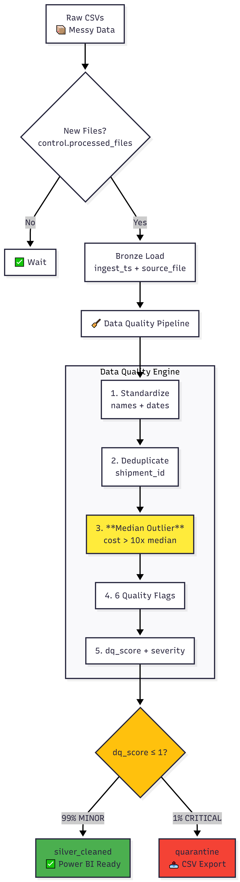
The pipeline follows a structured path to ensure data quality at every stage:
- Bronze Layer (Ingestion): Raw CSV files are ingested from the landing zone (/Volumes/logistics/bronze/shipments_vol/).
- Incremental Loading: To ensure efficiency, we use a control table (‘processed_files’) and a left anti join procedure to identify and process only new files.
- Silver Layer (Cleansing): Data is normalized, typed, and validated. Records are assigned DQ scores and routed to either "Cleaned" or "Quarantine" tables.
- Gold Layer (Modeling): Data is structured into a Star Schema optimized for Power BI performance.
2. Detailed Data Cleaning & Transformations
The Silver layer acts as the primary engine for data integrity. The following steps were performed in the Databricks notebook:
A. Standardization
- Normalization: All column names were converted to lowercase, and spaces were replaced with underscores for SQL compatibility.
- Trimming & Casing: Columns like carrier_id and delivery_status were trimmed of whitespace and forced to uppercase.
- Type Casting: Numeric fields like shipment_cost were cast to double, and date strings were converted to date types.
B. Deduplication Strategy
- Duplicates with the same shipment_id often occur due to late re-sends.
- How: We used a Spark Window function partitionBy("shipment_id") and orderBy(F.col("ingest_ts").desc()).
- Result: Only the most recent record (Row Number 1) is retained, ensuring the latest shipment status is reported.
C. Median-Based Outlier Detection
- Why: Standard deviation is easily skewed by extreme values. A median-based approach is more robust for detecting data entry errors.
- How: We calculated the median cost using approxQuantile("shipment_cost", [0.5], 0.01).
- Rule: Any record where the cost is greater than 10x the median is flagged as dq_cost_outlier.
- Data Quality (DQ) & Quarantine
We implemented a scoring system to govern data health. Every row is evaluated against specific business rules:
DQ Rule Table
Rule Name | Logic
dq_cost_null | Checks if financial data is missing.
Dq_date_anomaly | Checks if shipment_date is later than delivery_date.
Dq_invalid_status | Validates that status is “DELIVERED”, “IN_TRANSIT”, or “CANCELLED”.
Dq_cost_zero | Flags records with a cost of zero or less.
Routing & Efficiency
- DQ Score: We sum these flags into a dq_score.
- Severity: * MINOR (Score 0): Clean data, routed to silver_cleaned.
- MAJOR/CRITICAL (Score ≥ 1): Routed to Quarantine.
- De-quarantining: Quarantined data is exported to CSV for business correction, while the Gold layer remains 100% "clean" and trustworthy.
5. Gold Layer: Star Schema Design
The data model is designed as a Star Schema to ensure high performance in Power BI.
Dimension Tables (Context)
- dim_date: Created from unique shipment dates to allow for Time Intelligence (YoY, MTD).
- dim_carrier / dim_warehouse: These use Surrogate Keys (SK) generated via row_number().
- Unknown Handling: Missing carrier IDs are mapped to a -1 | UNKNOWN record to maintain referential integrity.
Fact Table (Metrics)
- fact_shipments: Joins cleaned shipments with dimension keys.
- Measures: Includes shipment_cost, delivery_days, and handling flags.
- Filtering: shipment_cost IS NULL records are explicitly excluded to protect financial KPIs.

